# **Resting and Reading**

**Zoe's avatar**

[Zoe](https://substack.com/@zoeffc)

Aug 09, 2024

Share

Howdy!

I am going to be totally honest. Work has been incredibly emotionally taxing for me lately. I considered skipping newsletter writing this week and taking a bit of a mental health break, but couldn’t discern the difference between a mental health break and allowing myself to stew in the yuck. So I am compromising.

I want to give y’all some book recommendations for these final dog days of summer. Here in North Carolina, we are getting some wet weather, which is perfect for reading (and less perfect for stewing in the yuck).

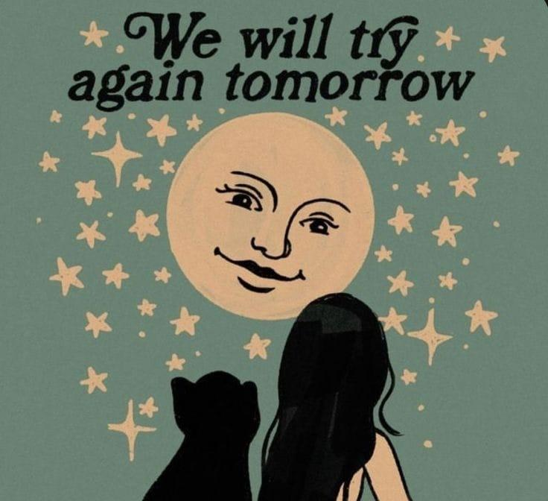

*Artist Unknown*

First some housekeeping:

📫 If a friend forwarded you this newsletter (then you have some really cool friends), and you may want to consider joining us [*here*](https://femme-futures.beehiiv.com/subscribe) for regular updates.

[Subscribe](https://femme-futures.beehiiv.com/subscribe)

🧲 Got some thoughts you want to share? Join us on [*Discord*](https://discord.gg/592wuyvx?utm_source=femme-futures.beehiiv.com&utm_medium=referral&utm_campaign=resting-and-reading) to chat all things newsletter and corporate life.

[Discord](https://discord.gg/N84WxemQ?utm_source=femme-futures.beehiiv.com&utm_medium=referral&utm_campaign=resting-and-reading)

📚 Books 📚

I am currently reading: *When Women Were Dragons* by Kelly Barnhill.

Fiction:

1. *Babel* by R.F. Kuang: something in my gut made me put this at the top of the list. Set in 1800s Oxford, this group of scholars confronts racism, the legacy of colonialism, and the intricacies of diverse friendships. There is a reason that this book has been so widely talked about. It is poignant, relatable, and challenging.
2. *Expiration Dates* by Rebecca Serle: this is a fun romance that circles around the idea of fate. Our main character receives notes from the universe after she meets a new romantic entanglement that tells her exactly how long the relationship will last. But one day, there’s no expiration date. Serle interrogates ideas of mortality, inevitability, and the dynamic nature of humans. I found it to be fun, though it is certainly not lighthearted.
3. *The Boy With the Bird in His Chest* by Emme Lund: this was a book club pic and I loved it. Lund captures some of our darkest thoughts and feelings in an incredibly human way. It is magical realism with its central character having a literal bird trapped inside his chest. We spent hours discussing what the bird might represent and never came to a clear answer. The bird was queerness and confidence and love and otherness and honesty and so much more. I will say that no one in my book club loved it quite as much as I did, but everyone was generally positive about it.

Nonfiction:

1. *Burnout: The Secret to Unlocking the Stress Cycle* by Emily Nagoski and Amelia Nagoski: I am on my second read-through of this book this year. If the name Emily Nagoski sounds familiar to you, she is a Smithie and the best-selling author of *Come As You Are*. In this book, she and her twin take on life's stress and give you tools for navigating it.
2. *Thank You More Please* by Lily Womble: this isn’t the first time that I’ve mentioned this book, but it was literally written for the same community that I have invited into the Femme Futures Cooperative. Instead of the workplace though, Womble takes on dating culture — something with less hard and fast rules to succeed at. In talking to overachievers and control freaks about this element of their lives that rejects control, she provides mindset tools and tricks to survive.

Other:

1. *Tuesdays with Morrie*: a whole lot less feminist than my nonfiction recs — I found a lot of the insights that this book provides to be incredibly thought-provoking. The premise is that Morrie is a retired university professor who is dying of ALS. As he deteriorates, one of his former students takes it upon himself to visit regularly and share the life lessons that Morrie imparts. A LOT of this book is about a white man realizing basic things like empathy MUCH later than he should have. However, I have a quote from the book that I keep tacked to my wall that reads: “love is the only rational act” and that essentially summarizes the book’s argument and is something that I still wrestle with ideologically.

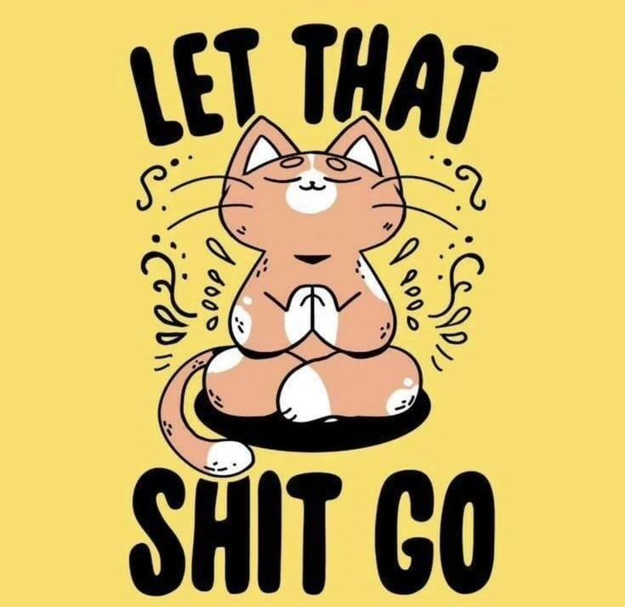

*Artist Unknown*

**Femme Futures Cooperative Founding Principles**

💚 **Mission**: The mission of Femme Futures is to create a community space for young professionals who identify as over-achievers and activists to generate collective su\ccess by providing resources and platforms to thrive in challenging workplace environments.

💙 **Vision**: To contribute to a world where driven individuals are equipped with the tools, guidance, and connections to overcome systemic barriers, fully utilize their talents, and enact positive change in their organizations and communities.